Semester One Examination, 2021

Question/Answer booklet

MATHEMATICS SPECIALIST
UNIT 3

Section Two:

Calculator-assumed

Your Name

Your Teacher’s Name

Time allowed for this section
Reading time before commencing work: ten minutes
Working time: one hundred minutes

Materials required/recommended for this section
To be provided by the supervisor
This Question/Answer booklet
Formula sheet (retained from Section One)

To be provided by the candidate
Standard items: pens (blue/black preferred), pencils (including coloured), sharpener, correction fluid/tape, eraser, ruler, highlighters

Special items: drawing instruments, templates, notes on two unfolded sheets of A4 paper, and up to three calculators approved for use in this examination

Important note to candidates
No other items may be taken into the examination room. It is your responsibility to ensure that you do not have any unauthorised material. If you have any unauthorised material with you, hand it to the supervisor before reading any further.
Question | Marks | Max | Question | Marks | Max
9 |  |  | 16
10 |  |  | 17
11 |  |  | 18
12 |  |  | 19
13 |  |  | 20
14 |  |  | 21
15

Structure of this paper

Section | Number of questions available | Number of questions to be answered | Working time (minutes) | Marks available | Percentage of examination
Section One:  Calculator-free | 8 | 8 | 50 | 49 | 34
Section Two:  Calculator-assumed | 14 | 14 | 100 | 96 | 66
 |  |  |  | Total | 100

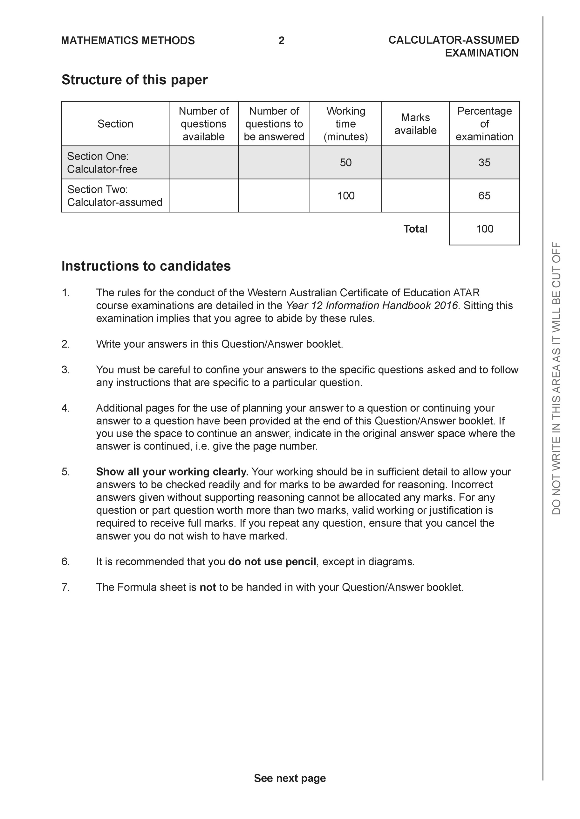

Section Two: Calculator-assumed (96 Marks)

This section has 14 questions. Answer all questions. Write your answers in the spaces provided.

Spare pages are included at the end of this booklet. They can be used for planning your responses and/or as additional space if required to continue an answer.
● Planning: If you use the spare pages for planning, indicate this clearly at the top of the page.
● Continuing an answer: If you need to use the space to continue an answer, indicate in the original answer space where the answer is continued, i.e. give the page number. Fill in the number of the question that you are continuing to answer at the top of the page.

Working time: 100 minutes.

Question 9 (6 marks)

- Sketch the locus of the equation on the axes below. (3 marks)

Solution
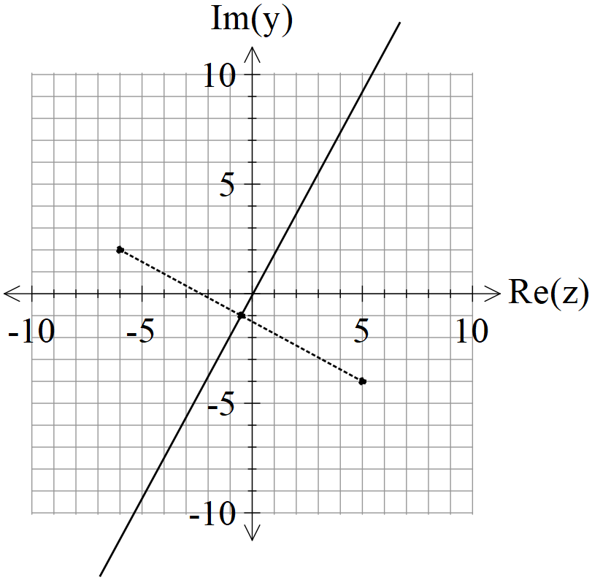

Specific behaviours
refers to two points shown on graph
uses perpendicular bisector
shows locus

- Determine the cartesian equation of this locus in terms of . (3 marks)

Solution
Specific behaviours
subs z=x+iy
squares both sides and expand real and imaginary terms
states cartesian equation, no need to simplify

Question 10 (9 marks)

Consider the locus as graphed below.

Determine the following.
- Maximum value of . (2 marks)
- Solution
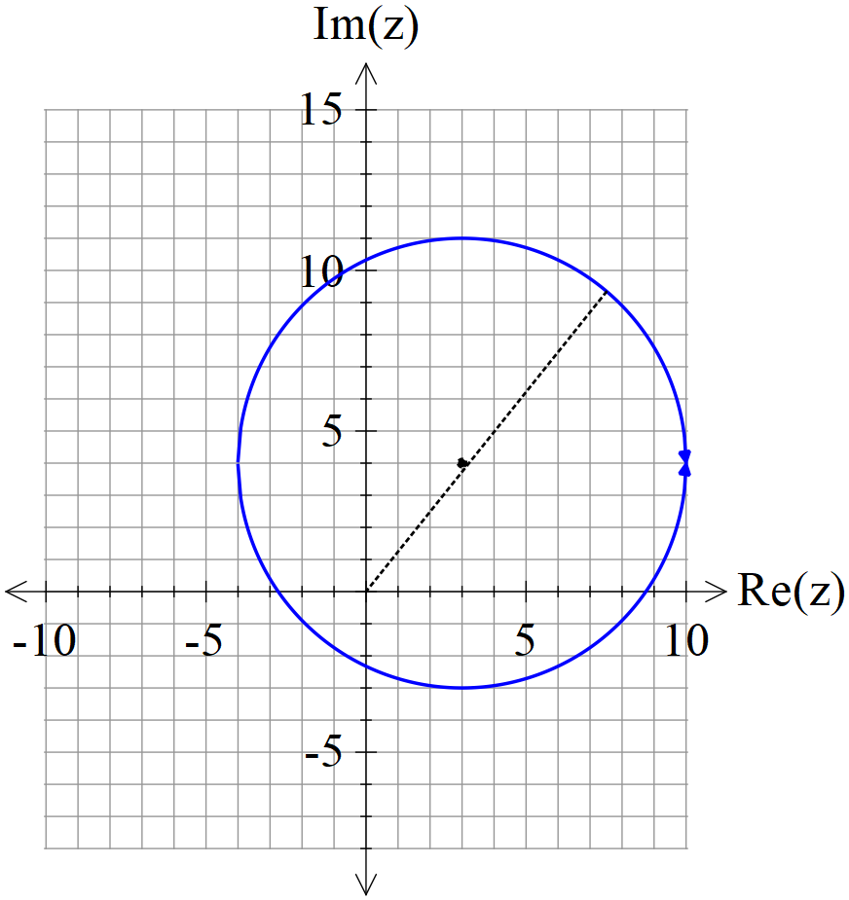

Specific behaviours
uses modulus of centre
determines maximum

- Minimum value of (3 marks)

Solution
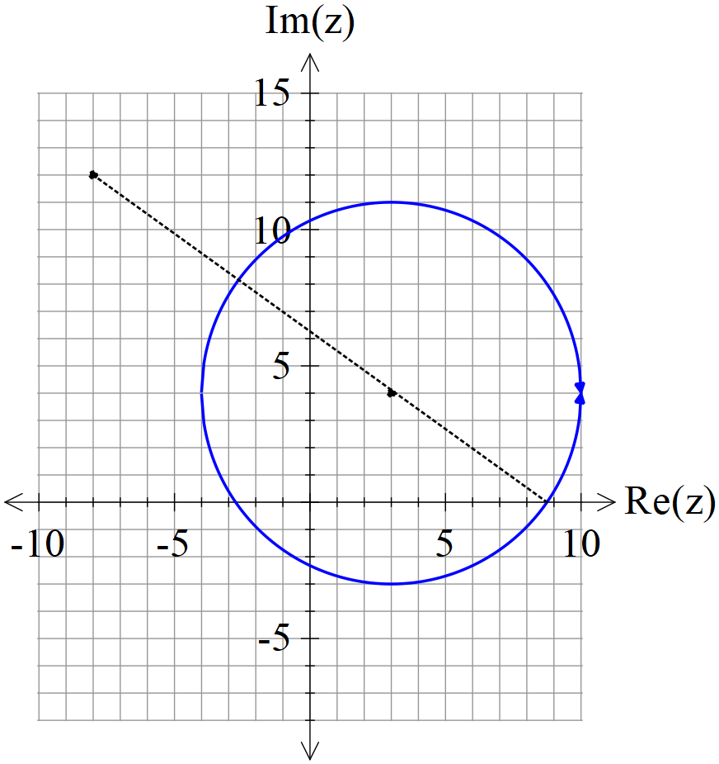
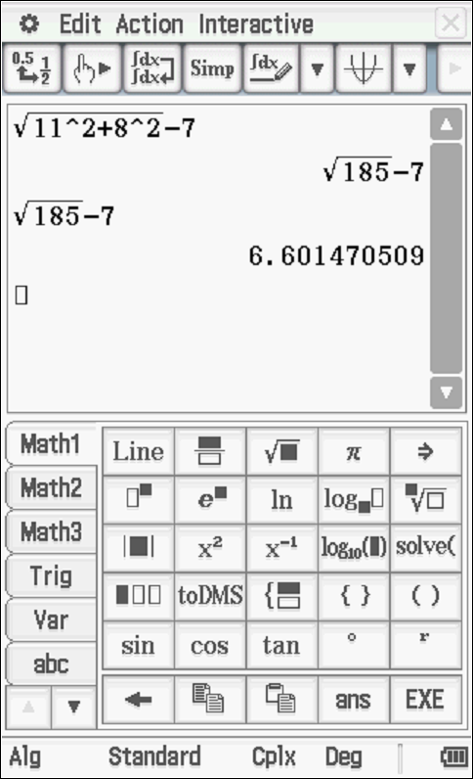

Specific behaviours
determines distance from (-8,12) to centre
subtracts radius
states approx. distance or exact

- Sketch the region defined by and on the axes above stating the coordinates of all boundary points. (4 marks)

Solution
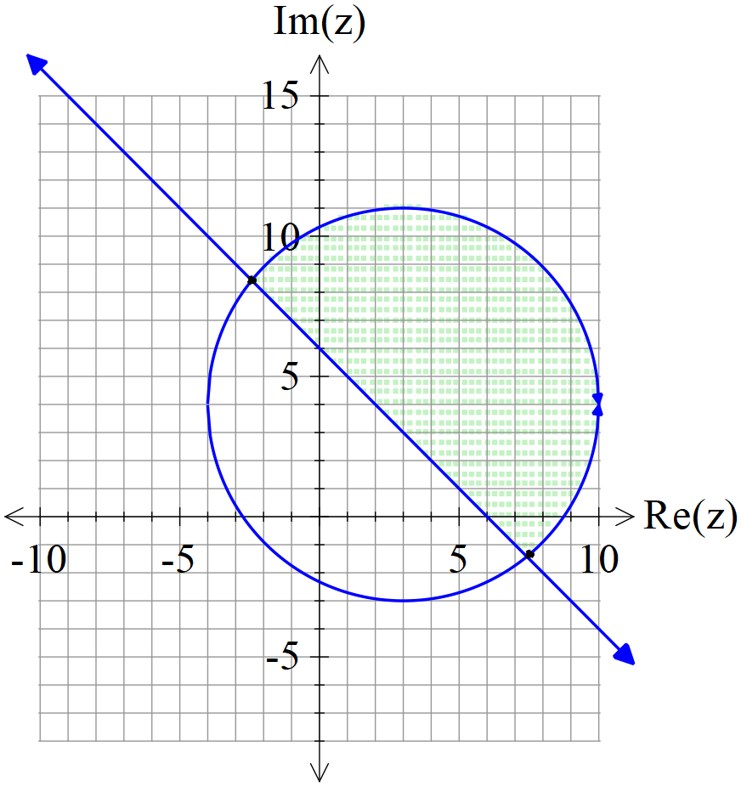
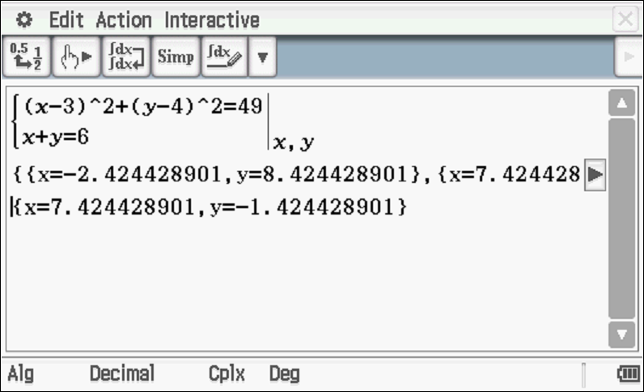

Specific behaviours
sketches line
shades above line and within circle to give required region
states approx. coords for one point
states approx. coords for two points

Question 11 (6 marks)

Consider the line and the point A.
- Using scalar dot product show how to find the closest distance of point A to the line above.
(3 marks)

Solution
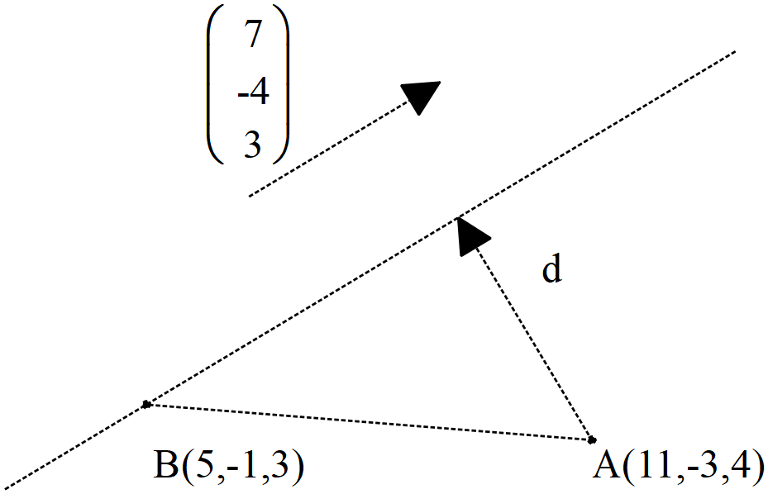

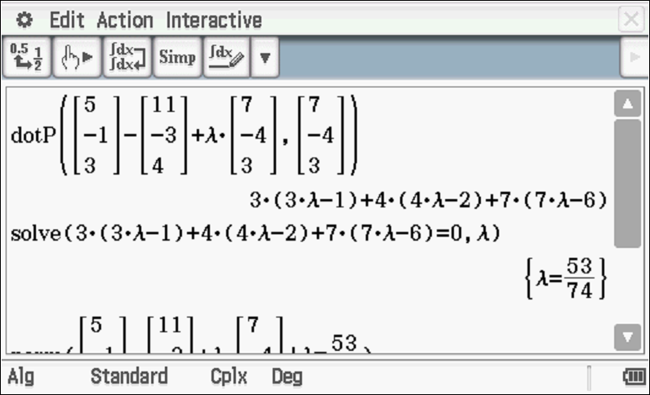
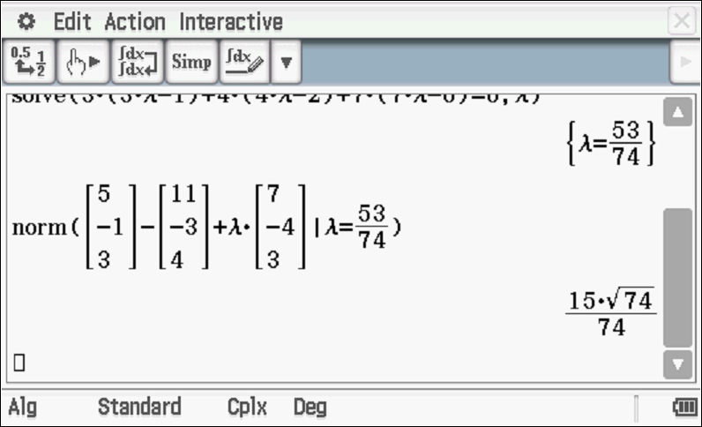
Specific behaviours
obtains expression for displacement vector
uses dot product and equates to zero
determines magnitude, accept approx

- Using vector cross product show how to find the closest distance of point A to the line above.
(3 marks)
Solution
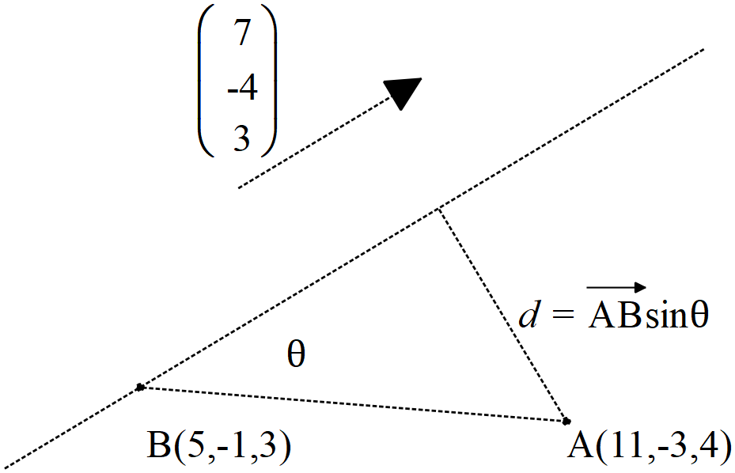

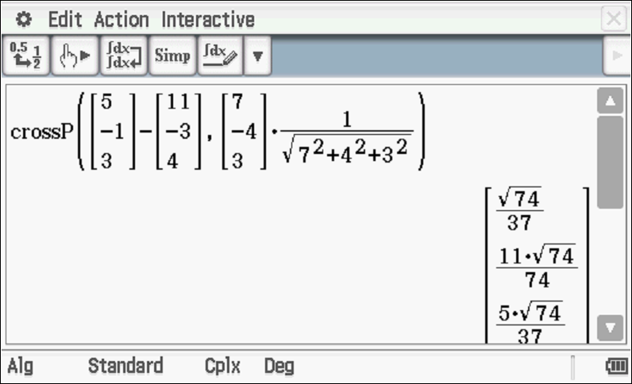
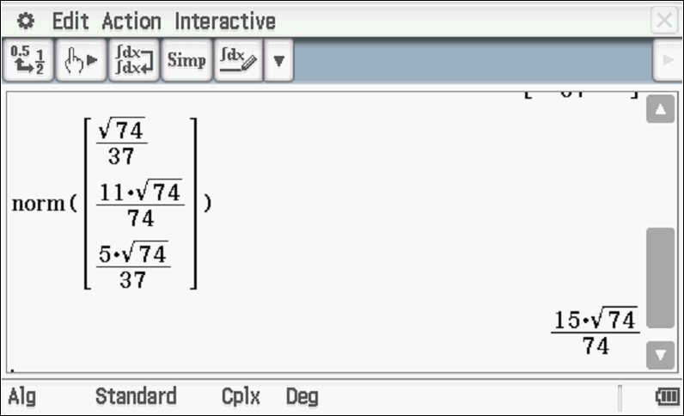
Specific behaviours
shows that sine is needed
uses cross product with unit vector
determines magnitude of cross product

Question 12 (9 marks)

Consider the sphere with being a positive constant and the line .

Determine all possible values of , (2 decimal places) for the following.
- The line does not meet the sphere at all.
- The line just touches the sphere at one point only.
- The line meets the sphere at two points.

Solution
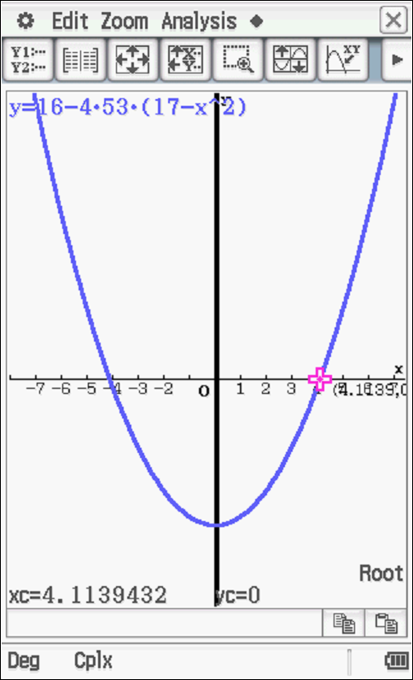
Specific behaviours
subs line into sphere
states a vector equation for parameter and alpha
derives a quadratic equation for parameter in terms of alpha
derives an expression for discriminant
equates discriminant to zero
writes two inequalities for discriminant
states interval of values for no solution (discards negative values) and 2 dp
states value for touching
states values for meeting at two points
(max -1 if not 2 dp)

Question 13 (4 marks)

Consider a prism where each side is a parallelogram with opposites sides congruent.
The units given are in metres.

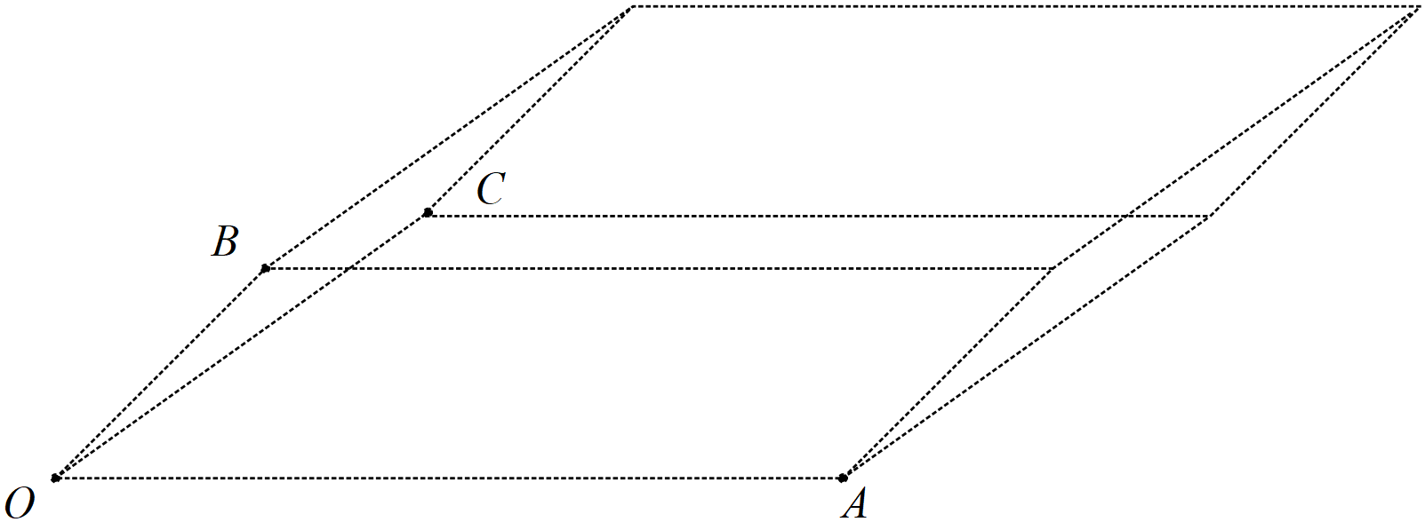

Given that and using vector methods, determine the volume of the prism.

Solution
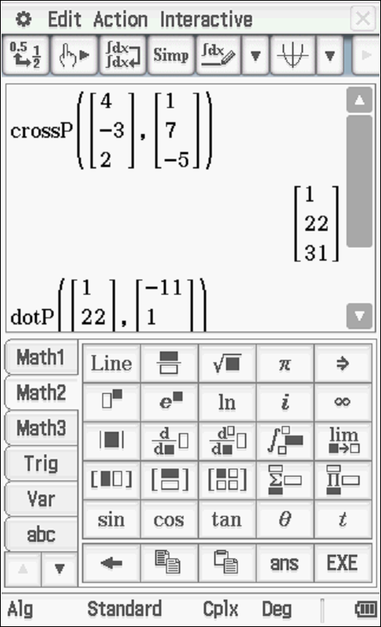
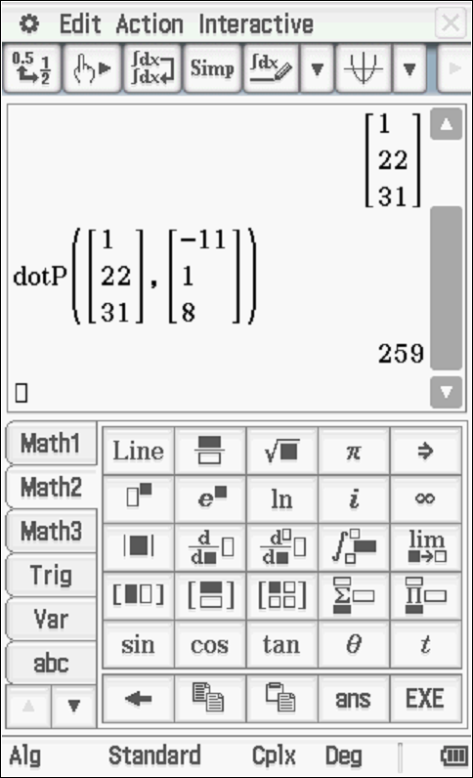
Volume = 259 cubic metres
Specific behaviours
uses vectors in calculation
uses area of face in calculation OR cross product
uses perpendicular width OR dot product with normal of face
determines volume with units
Question 14 (9 marks)

Consider the plane .

- Determine the distance of point A from the plane . (4 marks)

Solution
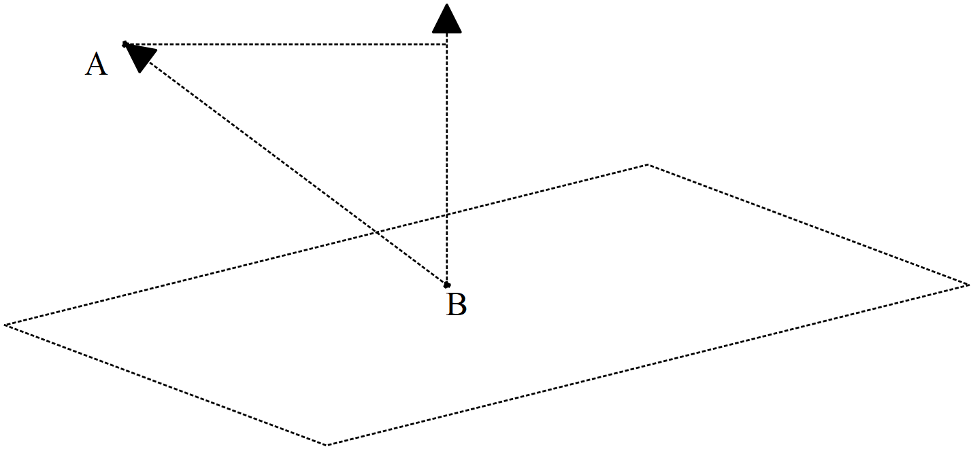

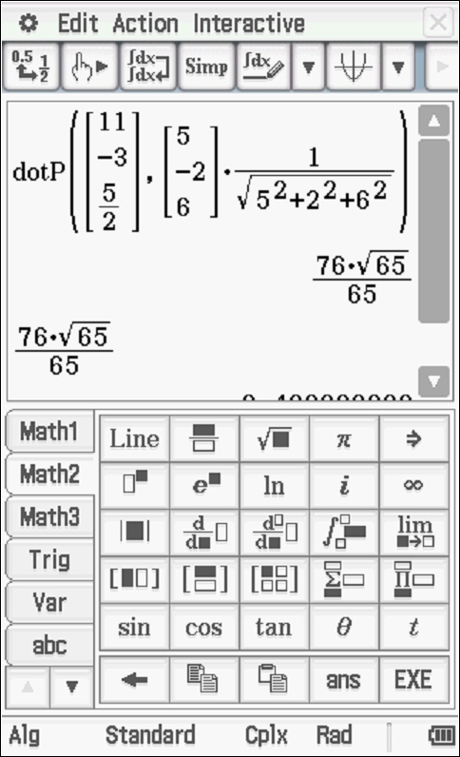
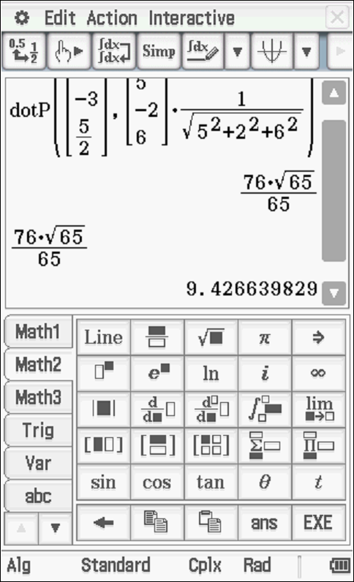
Specific behaviours
determines any point on plane B OR vector equation of line
uses dot product
uses normal vector
determines approx. distance

- Determine an expression in terms of for the distance of point P from the plane . (3 marks)

Solution
Specific behaviours
uses a vector of pt P to any point on plane
uses dot product with unit normal
determines expression within absolute value

- If point Ais on a plane parallel to , determine a vector equation for this parallel plane. (2 marks)

Solution
Specific behaviours
uses normal vector and dot product
states vector equation of plane

Question 15 (7 marks)

Consider two submarines A & B moving in deep ocean with constant velocities .
At 12:30am submarine A is at position and at 1am the same day
submarine B is at position .
- Determine the time, to nearest minute, that the submarines are closest to each other stating this distance to the nearest metre, (4 marks)

Solution
Let t=0 be at 1am
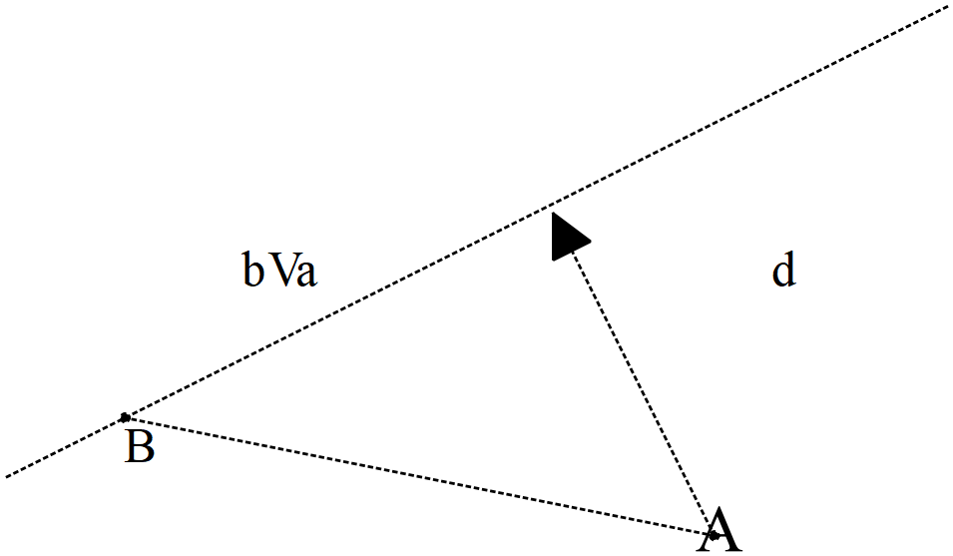

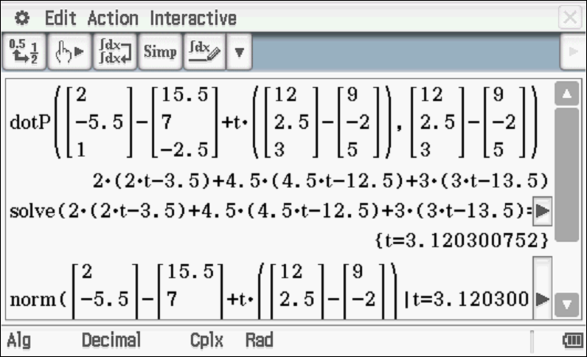
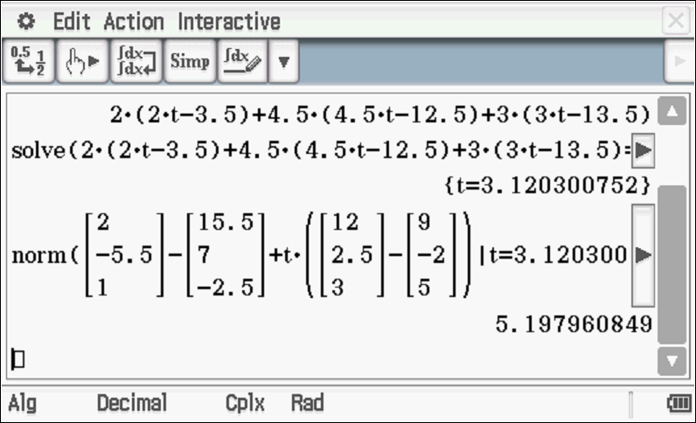
Closest approach at 4:07am at 5198 metres

Specific behaviours
determines position of both subs at the same time
sets up equation to solve for time at closest approach (dot or calculus)
states time at closest approach to nearest minute
states distance rounded to nearest metre
(max -1 if not rounded)

- If both submarines leave a lasting water trail of bubbles, determine if the trails cross and if they do at which position under water. (3 marks)

Solution
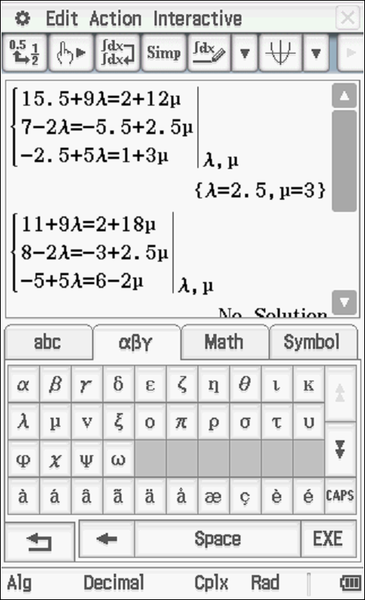

Bubble paths meet at (38,2,10)km
Specific behaviours
sets up equations with different parameters
shows that lines of bubbles do meet
states coordinates of such point

Question 16 (5 marks)

Consider the complex numbers such that:

Determine in the form where are real numbers.

Solution
Specific behaviours
determines Arg(p)
sets up equation for Arg(z) conjugate
determines modulus of p & w
determines Arg(z) & modulus of z
expresses z in cartesian form

Question 17 (11 marks)

Consider the 3D object as drawn below with the origin and

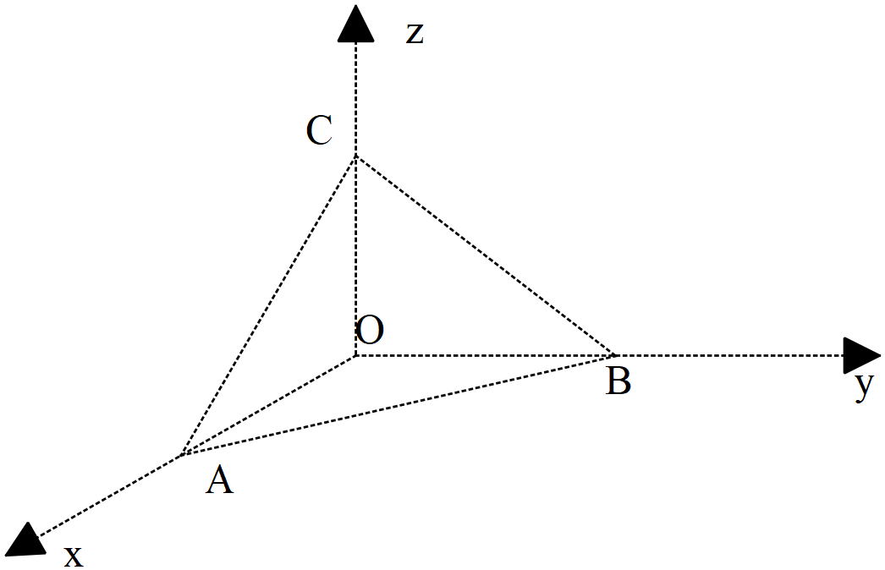
- Determine the vectors . (2 marks)
Solution
Specific behaviours
determines vector AB
determines vector AC

- Determine to the nearest degree the angle (2 marks)
Solution
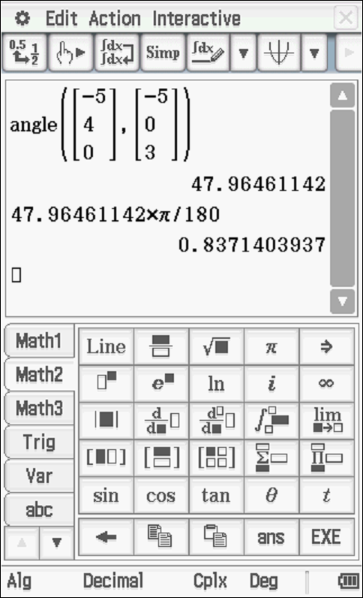

Specific behaviours
uses dot product
determines angle in degrees or radians(no need to round)

- Determine the exact area of triangle using vectors. (3 marks)

Solution
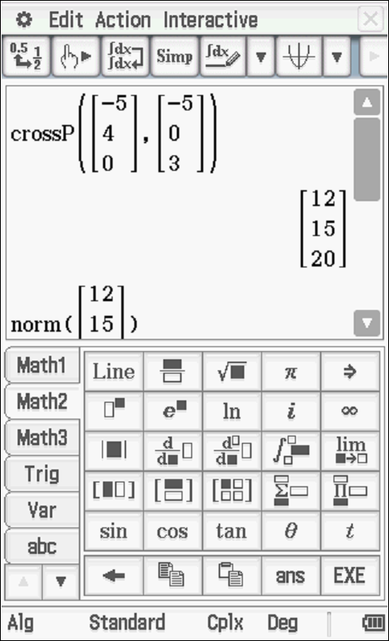
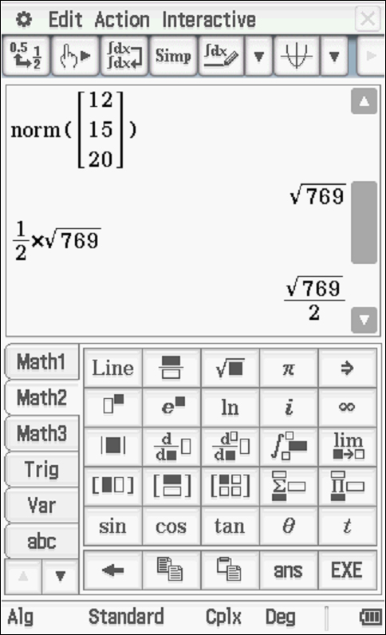

Specific behaviours
uses cross product
determined an expression for area
determined exact area

- Determine the cartesian equation of the plane containing triangle . (4 marks)

Solution


Specific behaviours
determines normal vector
sets up equation for vector equation
determines vector equation
determines cartesian equation

Question 18 (7 marks)

Consider the vectors
- Determine given that are parallel, is perpendicular to and is perpendicular to . (4 marks)

Solution
Specific behaviours
uses scalar multiple between a & b vectors
uses dot product equally zero for perpendicular
solves for one unknown
solves for all unknowns

- Given that , determine a vector parallel to but equal in magnitude to .
(3 marks

Solution
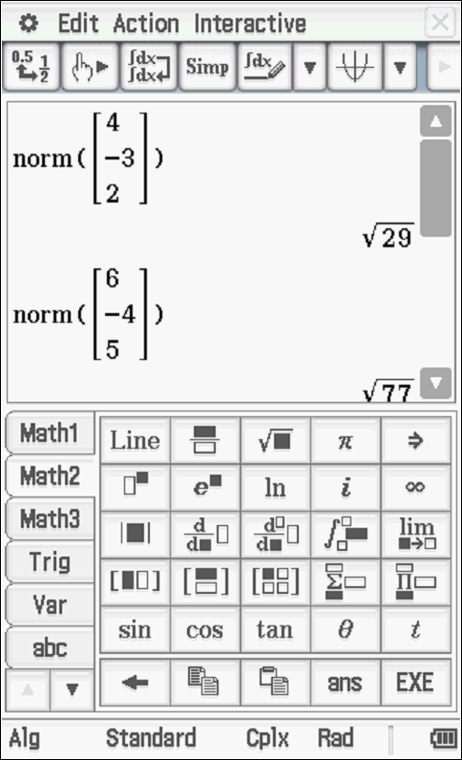
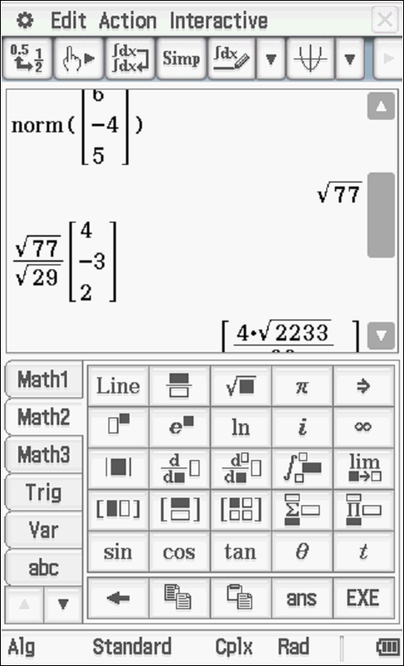

Specific behaviours
determines magnitude of a & e vectors
determines unit vector parallel to a
determines final vector (plus or minus)

Question 19 (7 marks)

- Consider the cartesian equation . Describe what this locus of points represents and state major features and give the vector equation.
(4 marks)

Solution
Sphere with centre (3,-4,1.5) with radius root29/2

Specific behaviours
completes the square for each variable
states vector equation
states a sphere with radius stated
exact radius stated

- Consider the equation where is a constant. Determine the values of for which the equation would be a sphere giving the centre and radius in terms of . (3 marks)

Solution
Specific behaviours
completes the square and states centre
all possible values of alpha (accept -14)
states general rule for radius

Question 20 (6 marks)

Let be a complex number such that and .
- Express in terms of the complex number . (simplify) (3 marks)

Solution
Specific behaviours
converts all number in polar form
simplifies modulus of total
simplifies argument of total

- Express in terms of . (3 marks)

Solution
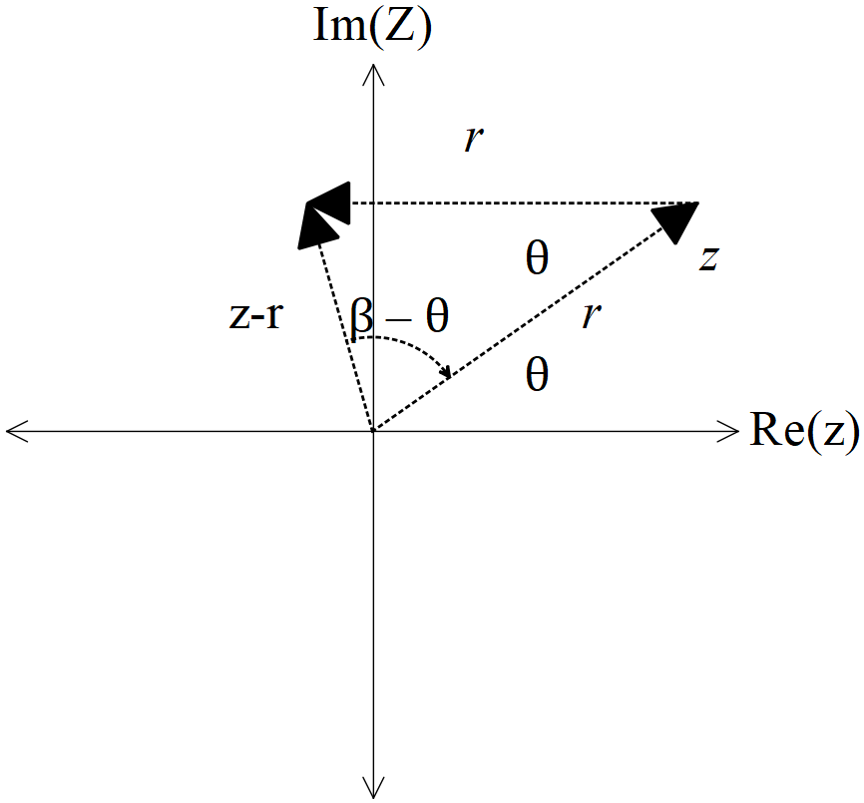

Specific behaviours
shows diagram of addition with labels
recognizes isosceles triangle
derives correct expression

Question 21 (4 marks)

Consider the polynomial where are real constants.
Given that and determine the values of .

Solution
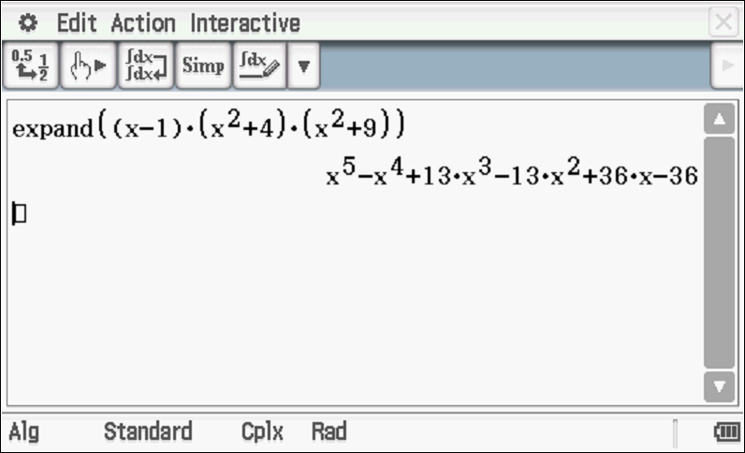
a=13, b=-13, c=36 & d=-36

Specific behaviours
shows that z=1 I a root
uses conjugates of complex roots in factorising
expresses polynomial as a product of factors
determines values of all unknowns

Question 22 (6 marks)

- Using De Moivre’s theorem, derive an expression for in terms of only.
(3 marks)

Solution
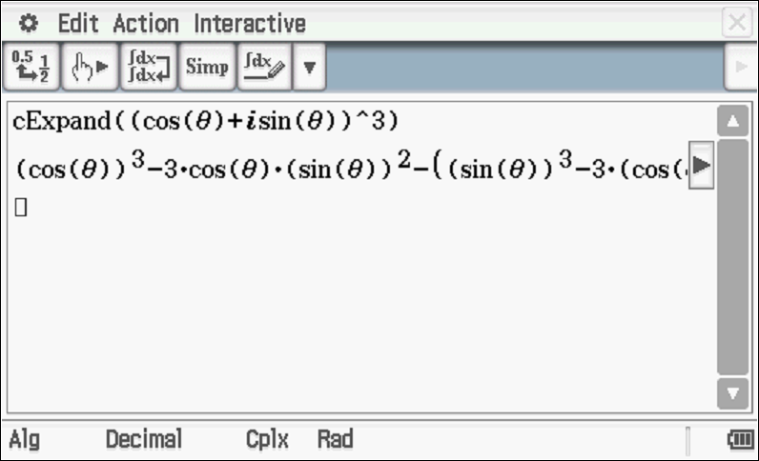

Specific behaviours
shows that expression is derived from real part of De Moivre’s use
expands expression of cubic
expresses all terms in cosine form

- Using the result from (a) above, show how to obtain all solutions to in the form . Express possible values of in exact form.
(3 marks)

Solution
Specific behaviours
expresses equation using result from cos3x
solves for three possible exact values of angle. NOTE- many other values possible
expresses all solutions in exact cosine form.
NOTE- decimal values or surd expressions from classpad will not be accepted for any marks

